**Text Box:**

Text box controls allow entering text on a form at runtime. By default, it takes a single line of text, however, you can make it accept multiple texts and even add scroll bars to it.

Let's create a text box by dragging a Text Box control from the Toolbox and dropping it on the form.

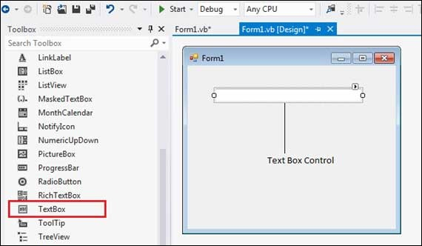

**The Properties of the Textbox Control**

The following are some of the commonly used properties of the TextBox control –

1.AcceptsReturn

Gets or sets a value indicating whether pressing ENTER in a multiline TextBox control creates a new line of text in the control or activates the default button for the form.

2.CharacterCasing

Gets or sets whether the Textbox control modifies the case of characters as they are typed.

3.Font

Gets or sets the font of the text displayed by the control.

4.FontHeight

Gets or sets the height of the font of the control.

5.ForeColor

Gets or sets the foreground color of the control.

6.Lines

Gets or sets the lines of text in a text box control.

7.Multiline

Gets or sets a value indicating whether this is a multiline TextBox control.

8.PasswordChar

Gets or sets the character used to mask characters of a password in a single-line TextBox control.

9.ReadOnly

Gets or sets a value indicating whether text in the text box is read-only.

10.ScrollBars

Gets or sets which scroll bars should appear in a multiline TextBox control. This property has values −

None

Horizontal

Vertical

Both

11.Text

Gets or sets the current text in the TextBox.

12.TextAlign

Gets or sets how text is aligned in a TextBox control. This property has values −

Left

Right

Center

**Events of the TextBox Control**

The following are some of the commonly used events of the Text control −

1.Click

Occurs when the control is clicked.

2.DoubleClick

Occurs when the control is double-clicked.

3.TextAlignChanged

Occurs when the TextAlign property value changes.

**Example**

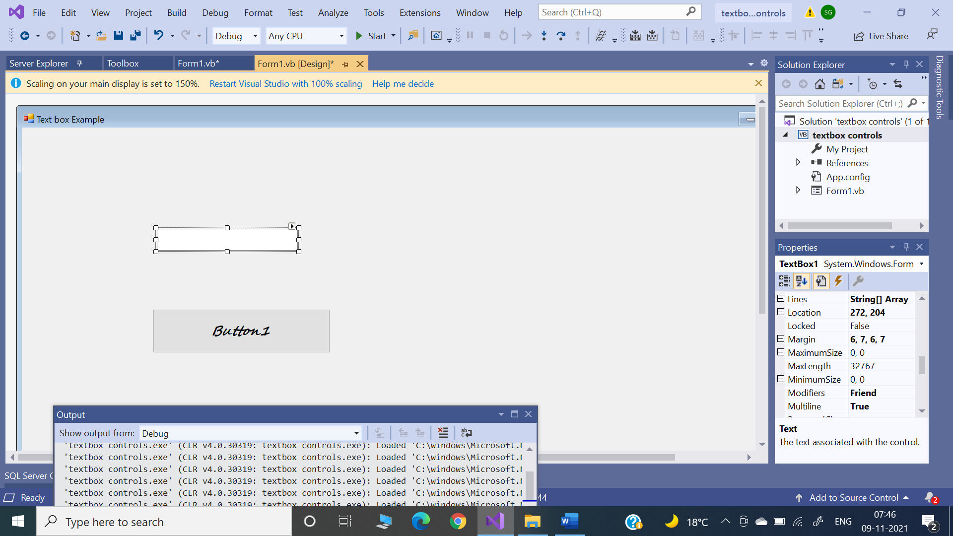

Private Sub Button1_Click(sender As Object, e As EventArgs) Handles Button1.Click

MessageBox.Show("Thank you " + TextBox1.Text)

TextBox1.Text = ""

End Sub

